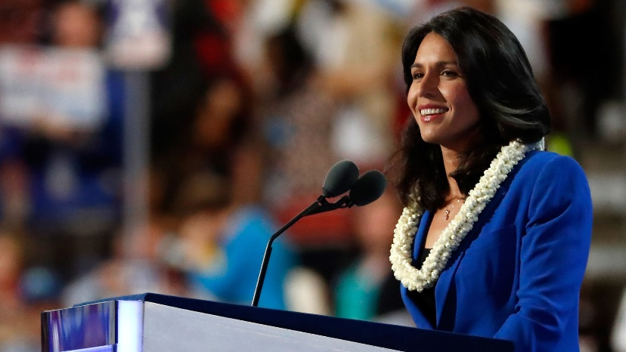
Rep. Tulsi Gabbard (D-Hawaii) is an Iraq War veteran who has bucked the Democratic establishment on a few high-profile occasions. During the 2016 primary, she resigned as vice chair of the DNC to throw her support behind Sen. Bernie Sanders. She also met with President Trump during his transition — and joined Republicans in promoting the use of the phrase "radical Islam."

Key facts about Gabbard
- Current position: Congresswoman from Hawaii since 2013
- Age: 37
- Born: Leloaloa, American Samoa
- Undergraduate: Hawaii Pacific University
- % of votes in line with Trump, per FiveThirtyEight: 21.7%
- Previous roles: Hawaii state legislature, Hawaii Army National Guard, Senate legislative aide, Honolulu City Council

Gabbard's stance on key issues
- Green New Deal: No stated position, but proposed a bill in 2017 to transition to 100% renewable energy to generate electricity by 2035.
- Medicare For All: Supports. Said that she doesn't want to eliminate private insurance.
- Abortion: Told the Rubin Report: "Unless a woman's life or severe health consequences is at risk, then there shouldn't be abortion in the third-trimester."
- Education: She wants to get rid of tuition and fees at 4-year public colleges and universities. She also supports free community college tuition for everyone.
- Also Sanders-esque: She has spoken about reducing the role of money in politics and has called for a reduced military presence in the Middle East.
- Big business: Supports breaking up big banks, per her campaign website.

Key criticism of Gabbard
- Syrian President Bashar al-Assad meeting: In what her office called a "fact-finding" mission, Gabbard made a secret trip to Syria in January 2017 and met with Assad. There are questions about the Arab American organization that funded the trip. She has also met with Egyptian President Abdel Fattah el-Sisi.
- Her LGBTQ record: When she was young, she worked for her father's anti-gay organization, and when running for state legislature in 2002, she talked up her support for her father's efforts to ban same-sex marriage in Hawaii. She has since apologized, saying that those positions were a result of her conservative upbringing.
- "Extreme vetting" vote: She voted with congressional Republicans on an Obama-era bill that would place "extreme vetting" measures on Iraqi and Syrian refugees.

1 fun thing about Gabbard
- She is the first American Samoan and first Hindu member of Congress.
- Big business: Supports breaking up big banks, per her campaign website.

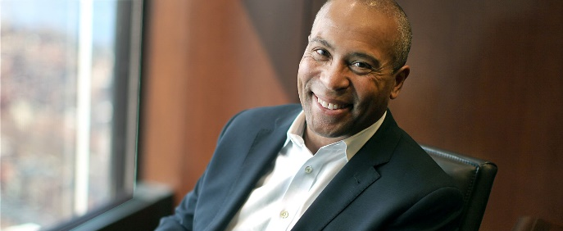
Democrat Deval Patrick is a businessman and was the first black governor of Massachusetts. He has close personal ties to former President Obama and some of his closest advisers.

Key facts
- Current position: n/a
- Age: 63
- Born: Chicago, Ill.
- Education: Harvard University (BA, JD)
- Date candidacy announced: Nov. 14, 2019
- Previous roles: Managing director at Bain Capital (2015-2019); Governor of Massachusetts (2007-2015), board of directors of ACC Capital Holdings (2004-2006), executive vice president at Coca-Cola (2001-2004), general counsel at Texaco (1999-2001), U.S. Assistant Attorney General for the Civil Rights Division (1994-1997)

Stance on key issues
- Medicare for All: Called it a "terrific idea" last year, but only "alongside various of the private options that are available" under the Affordable Care Act.
  - Signed legislation in Massachusetts linking cost increases in health care to the rate of growth of the state’s economy.
- Climate change: Advocated for a multi-pronged approach for tackling climate change, while calling cap-and-trade not "enough" of a strategy to carbon emissions.
  - In 2014, said "Massachusetts should finally end all reliance on conventional coal generation" in four years, and called for "a future free of fossil fuels."
- Immigration: As governor, allowed undocumented immigrants in Massachusetts to qualify for in-state tuition.
  - Proposed housing hundreds of undocumented immigrants at an in-state facility in response to an influx of migrants entering the U.S. in 2014.
- Gun control: Said after the Newtown shooting that he supports a renewal of the national ban on assault weapons.
- Education: Proposed doubling the number of charter schools in Massachusetts and imposing universal pre-K.
  - Proposed making community college free in the state.
- Abortion: Signed a law allowing police to order anti-abortion protesters to be removed from entrances to clinics if they were blocking access to the building.
- Opioid crisis: Signed into law a requirement for insurers to provide up to 14 days of inpatient care for people with addictions.

Key criticisms
- He entered the Democratic presidential field less than three months from the Iowa caucuses, missing the filing deadlines in Alabama and Arkansas.
- He has ties large corporations throughout his legal and business careers, which more progressive Democratic candidates have criticized during this election cycle.

1 fun thing
- A portion of a street in Patrick's Chicago hometown was renamed for him in 2013.
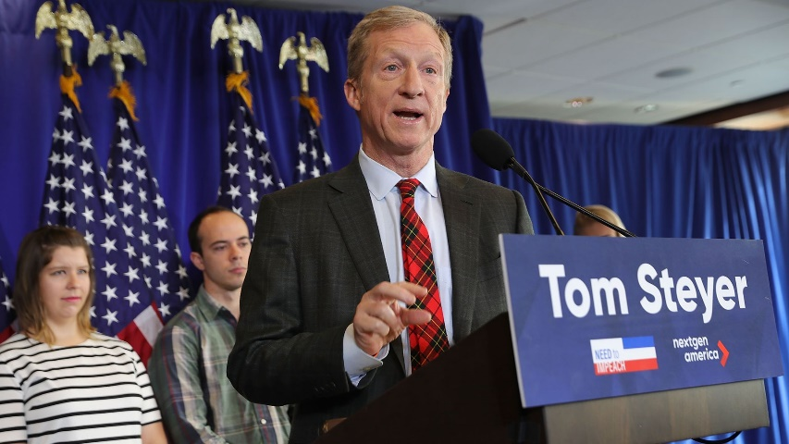
Billionaire Tom Steyer is a former hedge fund manager who's become known for his philanthropy and liberal activism. In 2017, he launched "Need to Impeach," spending $10 million on a national ad campaign urging Congress to impeach President Trump, according to Forbes. He has since resigned his position to pursue the Democratic nomination.

Key facts
- Current position: Philanthropist and activist
- Age: 62
- Born: New York, N.Y.
- Undergraduate: Yale University
- Date candidacy announced: July 9, 2019
- Previous roles: Founder of Farallon Capital, and nonprofits NextGen America and Need to Impeach

Key issues
- Climate change: The billionaire has a large stake in climate change. According to The Atlantic, Steyer is "frustrated" that Gov. Jay Inslee's climate-focused platform has not gained momentum. His organization, NextGen, has consistently promoted green-energy policies and a transition to a sustainable economy.
- Impeachment: Steyer's "Need to Impeach" campaign has long advocated for President Trump's removal from office.
- Big business: Steyer says he is committed to taking on corporations, stating in a press release that "the only way for us to solve the urgent problems facing our country is to loosen the stranglehold that corporations have over our politicians and return political power to the American people."
- Immigration: In a July tweet on the migrant crisis at the southern border, Steyer wrote that the Trump administration has "desensitized the Border Patrol to a shocking degree and made immigrants in desperation 'The Enemy."
- LGTBQ issues: Steyer has advocated for LGBTQ equality. In response to Trump's 2016 selection of Mike Pence as vice president, Steyer said the president had chosen "someone who had vilified another part of our community — the LGBT part of our community," Politico wrote.
- Housing: Proposes spending $45 billion per year in affordable construction and renovation. Wants to update the low-income housing credit by increasing allocations by 50% over the next five years.

Key criticisms
- Despite having sold his holdings in companies that generate fossil fuels, Steyer still bankrolled numerous projects that will continue to emit carbon into the foreseeable future.
- Steyer, who's launched his White House campaign condemning corporate America, may find himself at odds with his own business history. Farallon had $20 billion under its management when Steyer left.

1 fun thing
- Tom and his wife, Kathryn Taylor, have 4 grown children.
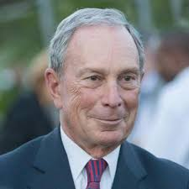
Michael Bloomberg is a late entry to the Democratic primary, launching less than three months out from the Iowa caucuses. The billionaire is known for his former role as mayor of New York City from 2002 to 2013 and his current position as CEO of Bloomberg LP.

Key facts
- Current position: Founder and CEO of Bloomberg LP
- Age: 77
- Born: Boston
- Undergraduate: Johns Hopkins University
- Graduate: Harvard University MBA
- Date candidacy announced: Nov. 24, 2019
- Previous roles: Mayor of New York City (2002–2013)

Key issues
- Climate: Has donated $500 million to an initiative to halt construction of new natural gas-fired power plants and to close all U.S. coal plants by 2030. Has called the Green New Deal unrealistic.
- Gun control: Supports universal background checks. Founder and primary financier of Everytown for Gun Safety, which advocates for stricter gun control legislation.
- Wealth tax: Has called for more progressive tax policy, but says the wealth tax proposed by Sen. Elizabeth Warren goes too far.
- Health care: Opposes Medicare for All, but says he would support giving Medicare to those who are uninsured.
- LGBTQ+ issues: Supports same-sex marriage and presided over New York City’s first official same-sex marriage the day it became legal. The Human Rights Campaign also named Bloomberg LP one of the "Best Places to Work for LGBTQ Equality."
- Immigration: Made several reforms in New York to help immigrants. His administration ensured confidentiality of immigration status for all people who interacted with the city government and spearheaded programs to help immigrant entrepreneurs start and grow businesses.
- Housing: Boosted affordable housing programs in New York, building 175,000 units between 2002 and 2013.
- Veterans: Provided priority job placement and assistance services to veterans and their spouses. Worked with the U.S. Department of Veterans Affairs to combat veteran homelessness.
- Gun control: Wants to boost background checks, close private sale and boyfriend loopholes, require permits for gun owners and ban assault weapons.

Key criticisms
- The Democratic Party has an increasingly unfavorable view of billionaires, specifically as it relates to their influence in politics. Bloomberg has an estimated net worth of $54 billion.
- While serving as mayor, Bloomberg also implemented the stop and frisk policing practice, which disproportionately affected people of color. He has defended the policy for years but apologized this month when it became clear he was preparing to run for president.

1 fun thing:
- Bloomberg is a licensed private pilot.

